Time: 9 am - 1 pm

Price $200 Monday-Thursday

The Sunset Ridge Junior Golf Academy consists of four consecutive sessions of PGA supervised instruction and practice.

We have excellent facilities with room for multiple stations and activities to provide new and experienced young golfers a great experience with plenty of hands on time in the game of golf.

The program focuses on basic skills and friendly competition in both long and short game as well as rules, etiquette and sportsmanship.

Loaner clubs are available if needed.

Participants must be able to walk and carry their own golf bag for as many as 9 holes.

The first 60-90 minutes of each day are spent learning the fundamentals of golf through drills and practice. After the morning break the remaining time features on course sessions to practice course management, rules and etiquette.

Students should bring their own sunscreen, a water bottle and snacks.

Typical Daily Schedule

8:45 Drop Off at Clubhouse

9:00 Roll Call – Safety Rules

9:05 Clinic/Practice Session

Monday – Putting
Tuesday – Short Game
Wednesday– Full Swing
Thursday- Review

10:30 Break

10:45 Skills Contests

11:15 On Course Session

12:45 Review/Recap

1:00 Dismissal

Safety First
FUN ALWAYS
FIRST RATE INSTRUCTION

how to customize

about the “picture” Fonts

workING with breaks

2019 Junior Golf Academy

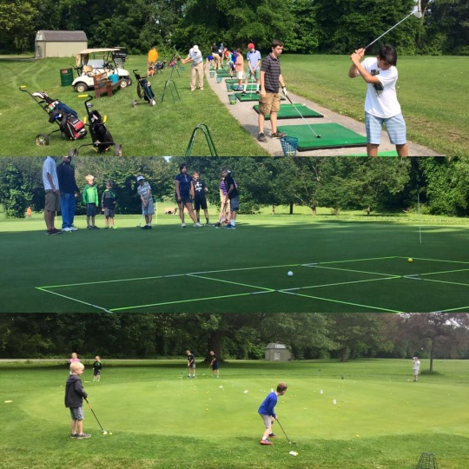
Sunset Ridge Golf Club
2814 W. Seneca Tnpk.
Marcellus, NY 13108
315-707-4503
www.sunsetridgegolfclub.com

Registration Form
Golfer Name: _______________________________________
Dear Parents,

Thank you for choosing The Junior Golf Academies at Sunset Ridge for 2019. Our goal is to provide a safe and fun filled experience for your kids to learn and enjoy the great game of golf! Our staff of 3 PGA professional’s will ensure your youth golfer gets top quality attention and minimal down time! Academies are divided into two age groups and two divisions (beginners and experienced). Golfers will be supervised and involved 100% of the time.

Please contact us anytime at 315-707-4503 to answer any questions. Spots will fill quickly so register ASAP!

Andrew Myers Philip Kless
Certified PGA PGA
Wade Malicky
PGA
Age: _______ Male_______ Female _______
Allergies: ____________________________________________
Has played 9 holes before? Yes________ No________
Has his or her own clubs? Yes_______ No_______
Has taken lessons before? Yes______No________
Parent/Guardian Information:
Name: ________________________________________________
Emergency Phone: _________________________________
E-Mail:________________________________________________
Registration Fee:
# of sessions/children ____ x$200 = _______
- discount ______ x $20 = ________
Total Due__________
Payable to: Sunset Ridge Golf Club

I hereby waive for my child any and all rights and claims for damages that we may have against Kless Myers Golf Management LLC, Sunset Ridge Golf Club and its successors and assigns for any and all injuries suffered by my child during the Junior Golf Academy. If a medical emergency should arise, those in charge have my permission to seek medical attention from qualified personnel.
Signed_________________________________________ Date_______________

Academy Dates

(Please Circle sessions being attended)

**$20 off for additional family children or single registry for multiple camps**

Dates
July 15th - July 18th
August 5th – August 8th

Camp is recommended for ages 7 – 17.

Younger campers can be admitted on a case by case basis. Please contact us to discuss.

For More information contact
315-707-4503
www.sunsetridgegolfclub.com

$95 / Academy includes:

- Daily PGA Instruction
- Use of golf course
- Equipment (or bring own)
- Meet new friends
- 8 to 1 Student/Pro Ratio
- Contests/Prizes
585-424-2920

Company Name
Street Address
Address 2
City, ST ZIP Code
Phone (555)555-0125
Fax (555)555-0145
Web site address

